Basic Low Pass Filtering in Python

Filtering

answer A: Move the filtered curve so that it aligns for the unfiltered curve. Put the resulting graph in your report.

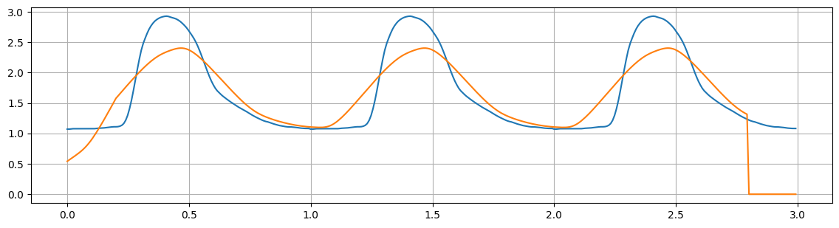
Figure 1. Aligned, padded filtered curve with unfiltered curve for M=50.

answer B: To get a flat line on the average, what M do we need? What happens if M is larger than that? Show some example plots in your report. Mark them with the used M.

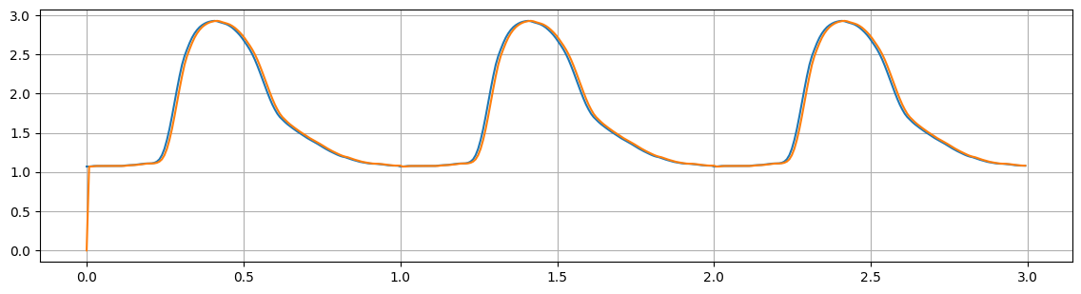
Figure 2. Non-aligned, non-padded filtered curve with unfiltered curve for M=1.
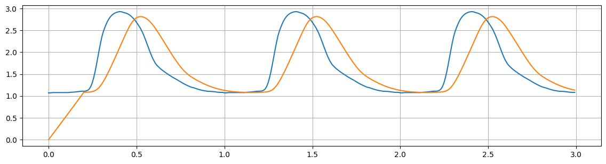
Figure 3. Non-aligned, non-padded filtered curve with unfiltered curve for M=25.
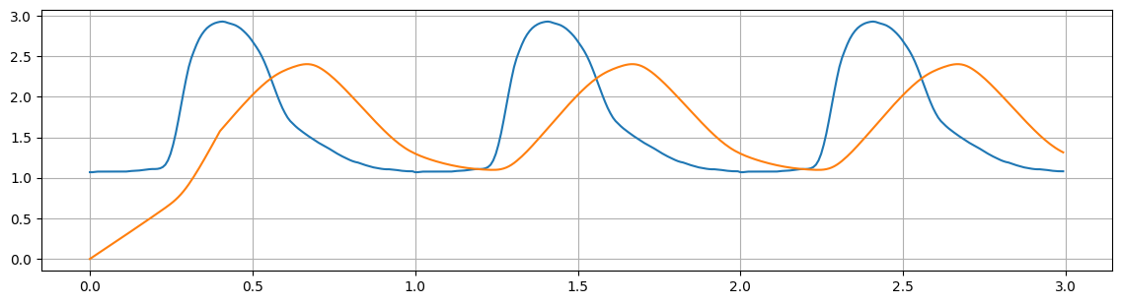
Figure 4. Non-aligned, non-padded filtered curve with unfiltered curve for M=50.
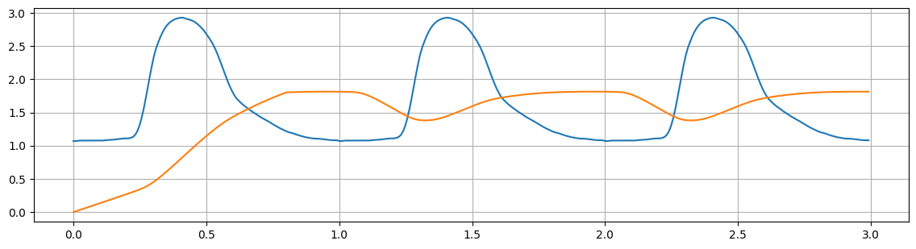
Figure 5. Non-aligned, non-padded filtered curve with unfiltered curve for M=100.
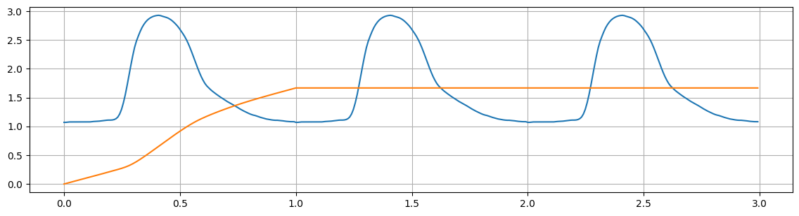
Figure 6. Non-aligned, non-padded filtered curve with unfiltered curve for M=125.
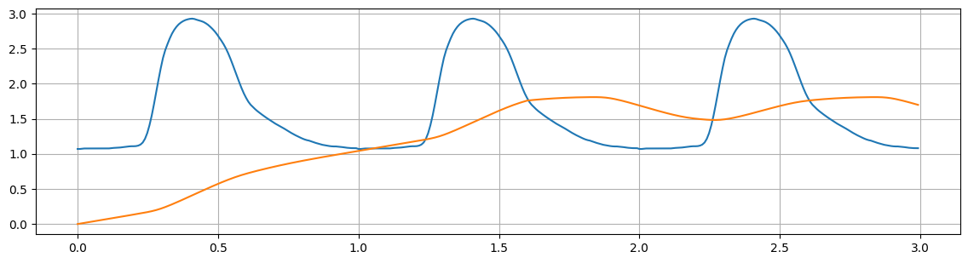
Figure 7. Non-aligned, non-padded filtered curve with unfiltered curve for M=200.
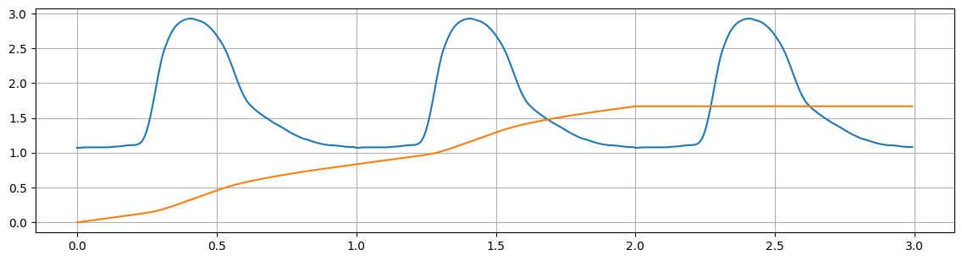
Figure 8. Non-aligned, non-padded filtered curve with unfiltered curve for M=250.
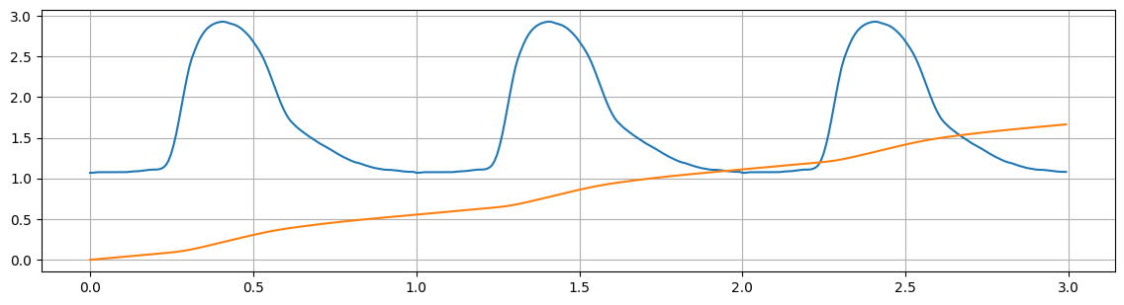
Figure 9. Non-aligned, non-padded filtered curve with unfiltered curve for M=375.
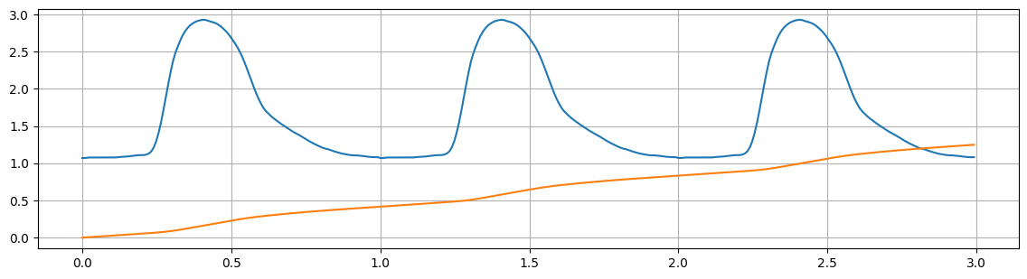
Figure 10. Non-aligned, non-padded filtered curve with unfiltered curve for M=500.

The signal $S$ consists of three repeats of one cycle with period $P=125$ samples. For each $M$ that is a multiple of $P$, i.e., $M=c∙P$, where $c$ is the number of cycles, the moving average becomes a constant value equal to the mean of one full cycle. Nevertheless, the filter must first accumulate enough samples to fill the averaging window. For samples computed before a full window, i.e., $y_{n}<y_{M}$, a filtering (or processing) delay is exhibited due to the missing samples (to fit the window) being set to zeros, i.e., zero-padding. As a result, the average in this region is lower. Consequently, when the window is set to $M=c∙P$, the flat line appears only after $c$ cycles, as shown in Figures 7, 9, and 10.

If the window size exceeds the total signal ($M>375$), the averaged output gradually decreases with increasing $M$. Again, this occurs because the additional samples (to fit the window) are set to zero. Therefore, as $M$ approaches infinity, the averaged output theoretically approaches zero.

General FIR Filters

answer C: Can you see what filter we have implemented?
Hint: Does it match any formulas from your basic calculus course? Note how it crosses the zero line exactly at time same time as the signal reaches its peak.

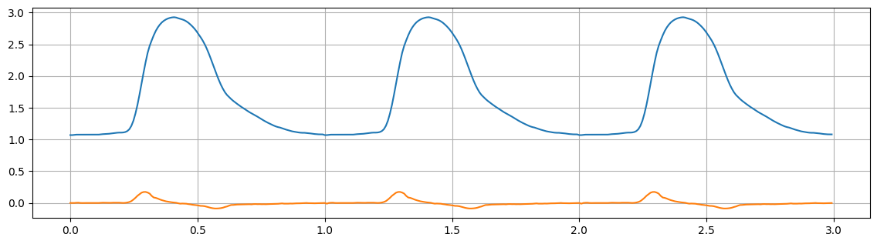
Figure 11. Non-aligned, non-padded discrete-time first-derivative (differentiator) filter.
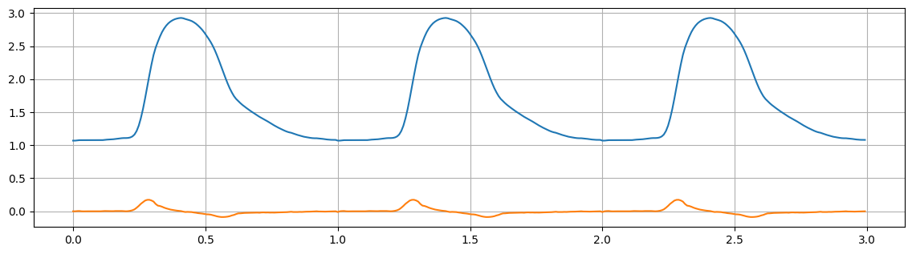
Figure 12. Aligned, zero-padded discrete first-derivative (differentiator) filter.

The filter measures the change in signal value per sample step, making it a discrete first-derivative (differentiator) filter. It approximates the rate of change ${dy}/{dx}$.

answer D: For the examples above, how can we best describe them?

Filter h | Type / Description | Effect on the signal
[10] | Amplification filter | Amplifies the signal by 10.
[-1] | Inverting filter | Inverts the signal.
np.ones(50)/50 | Moving average (low-pass) | Smooths the signal by averaging over 50 samples. Removes high-frequency noise. Causes delay.
[10,0,0,0,-10] | Edge/derivative (high-pass) | Detects rapid changes. Sensitive to high-frequency signals.
[0,0,0,0,0,1] | Delay filter | Shifts the signal samples to the right, without changing the shape of the curve.

answer E: Try some more arrays of your own.

Filter h | Type / Description | Effect on the signal
np.array([0.5, 0.5]) | 2-tap simple averaging | Averages the signal over two samples. Basic low-pass filter.
np.array([1, 0, -1]) | Centered first-derivative | Measures the slope around the current point. Better symmetry than np.array([1, -1]).
np.array([1, -2, 1]) | Second derivative (Laplacian) | Detects curvature (sharp peaks or valleys.)

Convolution

Noise

answer F: Try to use a larger window. How large window do you need before the noise is almost gone?

The noise is almost gone for a window size of $M=25$.

answer G: Can you reduce the window size and find a better filter by choosing other h_{k} values? Hint: Look at the sinc-function or the Hann-function.

L = 15 # Number of taps (window size)

fc = 5 / 62.5 # normalized cutoff (cutoff / Nyquist)
n = np.arange(L) - (L-1)/2 # center indices
h = np.sinc(2 * fc * n) # sinc function
h = h / np.sum(h) # normalize

h = np.hanning(L) # Hann function
h = h / np.sum(h) # normalize

Frequency analysis

answer H: Run the FFT on the signal with noise. How does it compare to the two FFT-curves of the signal and the noise?

When performing the FFT on the signal with added noise, the resulting frequency spectrum is the sum of the spectra of the original signal and the noise. This follows from the linearity property of the Fourier Transform:

$$F\{x1​+x2​\}=F\{x1​\}+F\{x2​\}$$

Thus, the frequency-domain additivity holds, allowing identification and separation of the noise from the useful signal components.

from scipy.fftpack import fft,ifft,fftshift

noise = N[:125] # Let's only extract 125 samples from N

Sf = fft(signal)
Nf = fft(noise)
n = len(signal)
T = 1.0
Sf[0] = None # Let's remove the DC component (0th frequency) for clarity!

fig = plt.figure(figsize=(14,6))
plt.plot(np.linspace(-n*T/2,n*T/2,n), 1.0/n * np.abs(fftshift(Nf))) # Noise
plt.plot(np.linspace(-n*T/2,n*T/2,n), 1.0/n * np.abs(fftshift(Sf))) # Signal

plt.plot(np.linspace(-n*T/2,n*T/2,n), 1.0/n * np.abs(fftshift(Sf+Nf))) # Signal + Noise

plt.grid()
plt.show()

FIR Filter design

answer I: Try to fix this by modifying the values in the website and try again and again, and again, until you are able to nearly recover the original curve without the noise. Include the plot in your report. How many taps do you need?

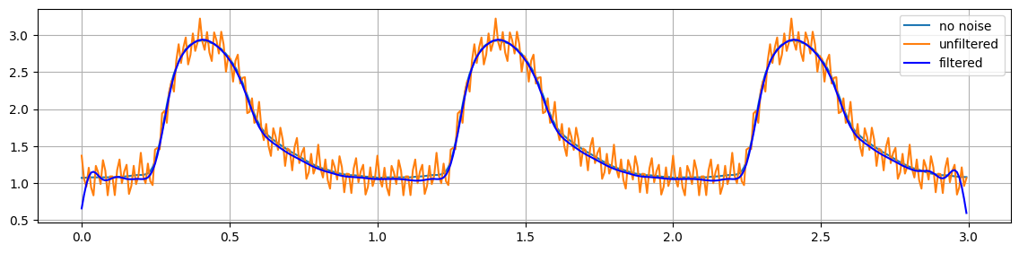
Figure 13. FIR Filter design using TFilter website with 45 taps.

answer J: Try to reduce the number of taps to see what happens. Make sure not to amplify or attenuate the sought signal.

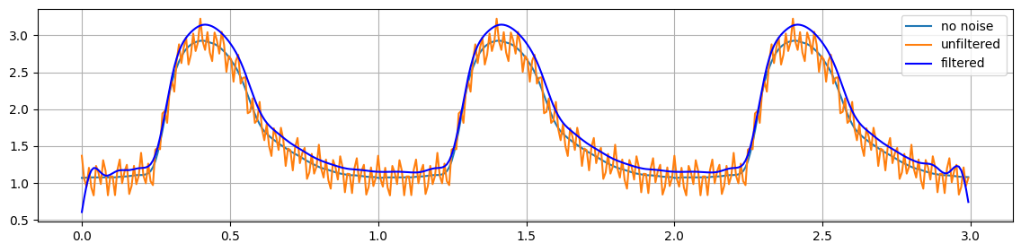
Figure 14. FIR Filter design using TFilter website with 44 taps.
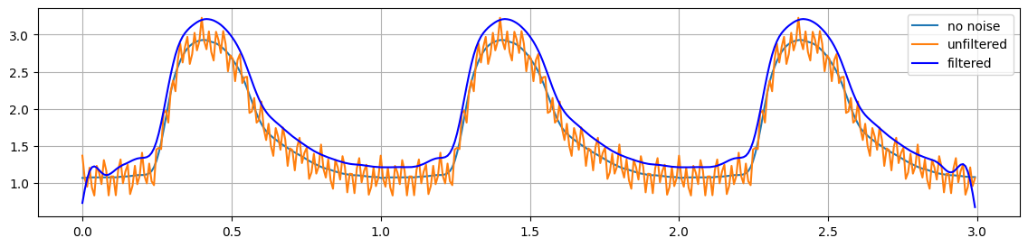
Figure 15. FIR Filter design using TFilter website with 35 taps.

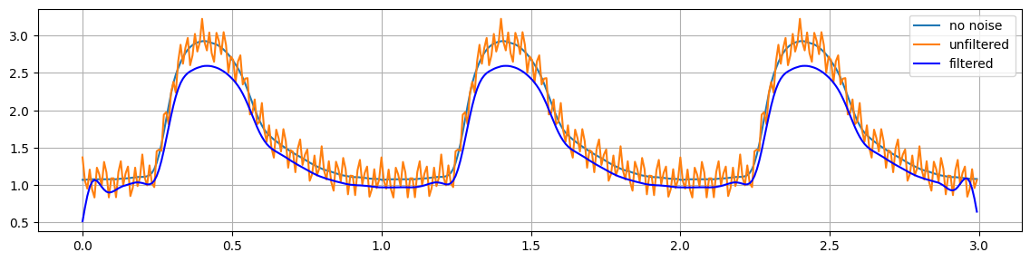
Figure 16. FIR Filter design using TFilter website with 34 taps.
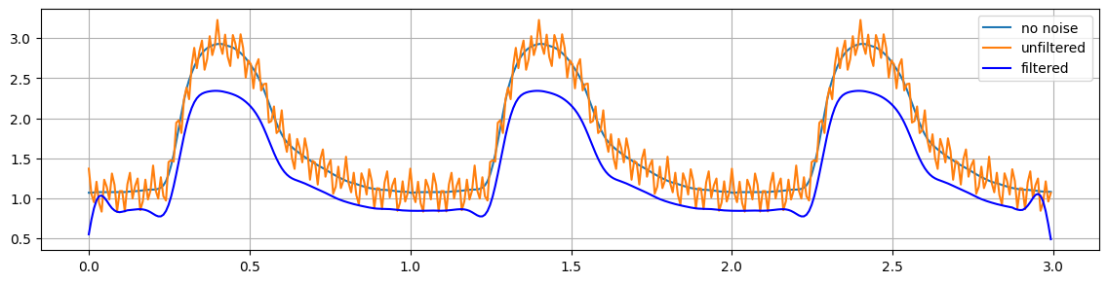
Figure 17. FIR Filter design using TFilter website with 31 (using minimum command) taps.
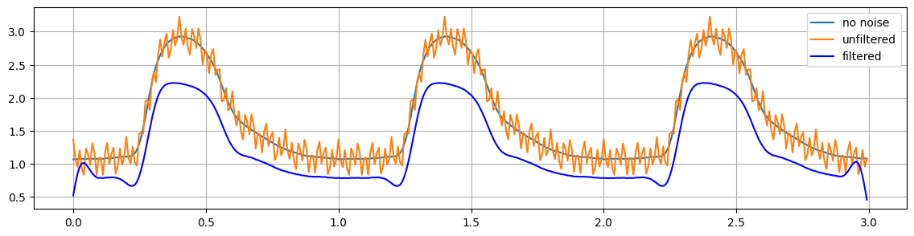
Figure 18. FIR Filter design using TFilter website with 25 taps.

A distinct pattern emerges as the window size, i.e., the number of taps, decreases from the optimal value of 45 taps. When the size is reduced by one tap, the filtered curve shifts upward, clearly rising above the unfiltered curve (Figure 14). This upward trend continues until the window size reaches 35 taps (Figure 15). Beyond this point, further reductions cause the filtered curve to shift below the unfiltered curve (Figures 16-18). Note, in Figure 17, a minimum command was used to determine an ideal low-pass filter, represented by the coefficients in the $h$ array.

answer K: Can you find a filter with similar performance as above? Include in your report the plot and the parameters used in the signal.firwin() call.

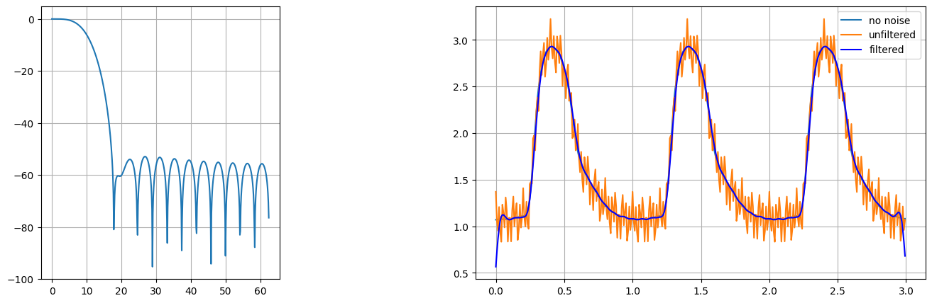

numtaps = 30
cutoff = 10 #Hz
win = 'hamming'
#win = ('kaiser', 8)

h = signal.firwin(numtaps, cutoff, window=win, fs=125)

answer L: Draw the frequency response curves for the moving average filters of different lengths. Also draw it for the other examples above.

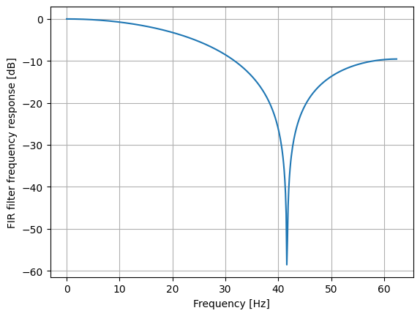
Figure 19. Frequency response for moving average filter: h = np.array([1,1,1])/3.0
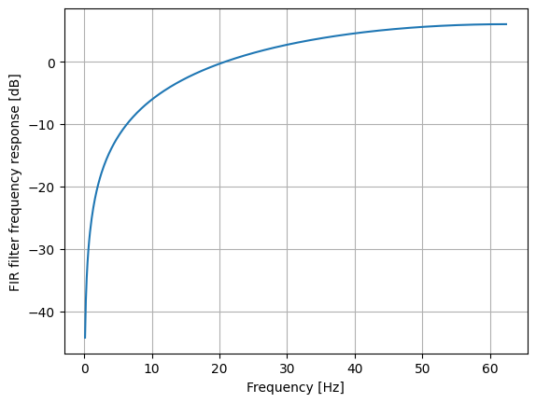
Figure 20. Frequency response for moving average filter: h = np.array([1,-1])
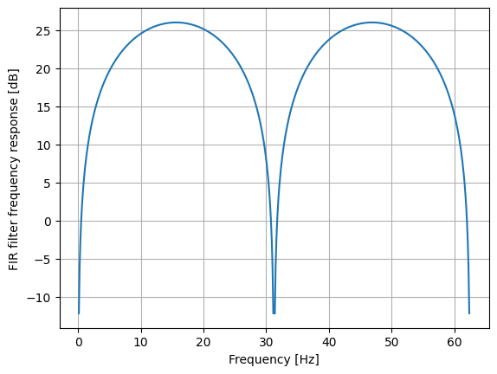
Figure 21. Frequency response for moving average filter: h = np.array([10,0,0,0,-10])

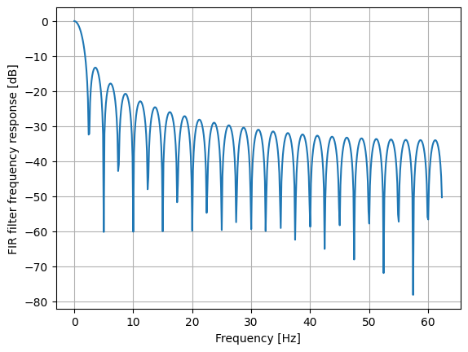
Figure 22. Frequency response for moving average filter: h = np.ones(50)/50.0
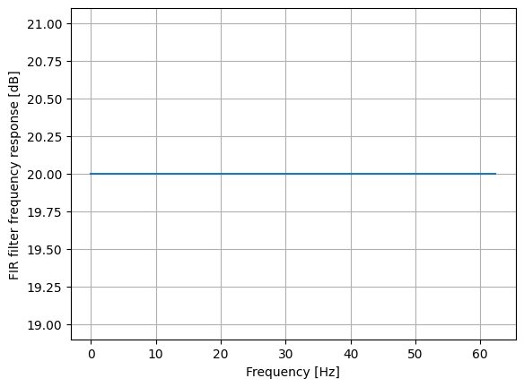
Figure 23. Frequency response for moving average filter: h = np.array([10])
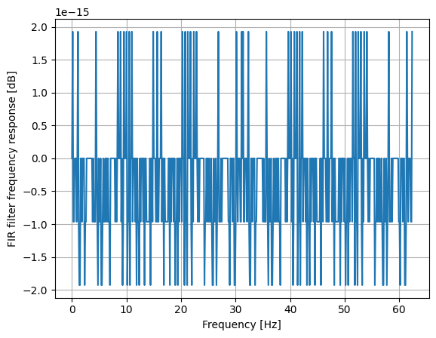
Figure 24. Frequency response for moving average filter: h = np.array([0,0,0,0,0,1])

IIR Filter Design

Answer M: What is the cut-off frequency for the EWMA that you used in Lab 1? Answer for both the smoothed signal and the "average"-curve. Also estimate the sampling frequency fs that your Lab 1 solution actually achieved. Make sure to indicate in your answer: fs and the α-values that you used.

As shown in Figures 25 and 26, the cut-off frequencies for the average and smoothed signals—based on a sampling frequency of 70 Hz—are estimated to be approximately 2.5 Hz and 8 Hz, respectively. Using the Lab 1 data, the sampling frequency was determined as the average BPM over 10 seconds, since the MakeCode program only samples when the period of one cycle is equal to or longer than the minimum period of a single heartbeat (where the maximum BPM was set to 200).

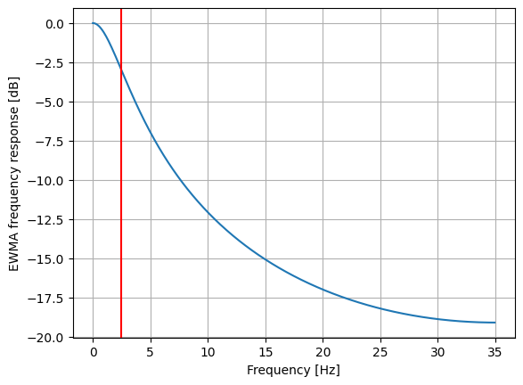
Figure 25. Cut-off frequency (red line, ~5 Hz) for the average signal (alpha=0.2).
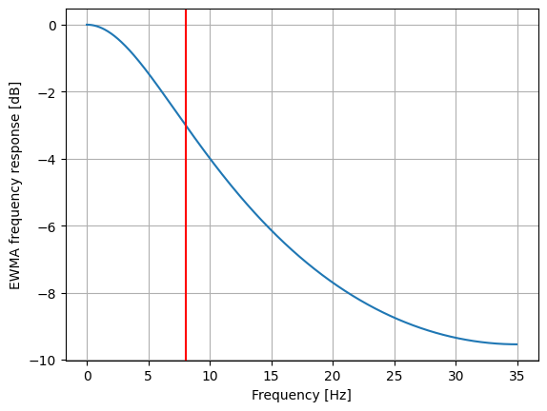
Figure 26. Cut-off frequency (red line, ~13 Hz) for the smooth signal (alpha=0.5).

Answer N: Add the noise (N) to the original signal and apply the EWMA and show that you can remove most of the noise for both the "average"-curve and the smoothed signal. Include the diagram in your answer.

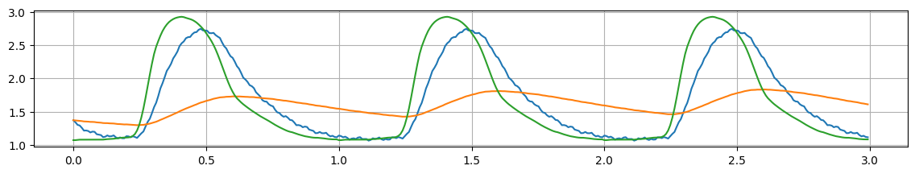

The Filter Function

Answer O: Design a Chebyshev type II and a Butterworth filter that can preserve our PPG signal (0-10 Hz) and attenuate the noise (15 Hz and 40 Hz) by at least -30 dB. What arguments to the butter() and cheby2() functions did you use? Include the frequency response charts in your answer.

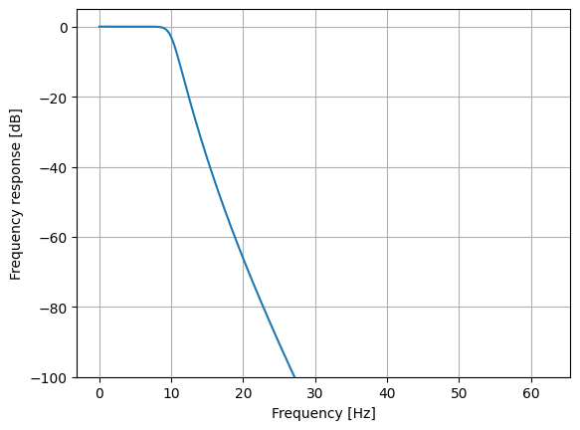
Figure 27. The filter function for butter() function: b,a = scipy.signal.butter(10, 10, btype='lowpass', analog=False, fs=125, output='ba')
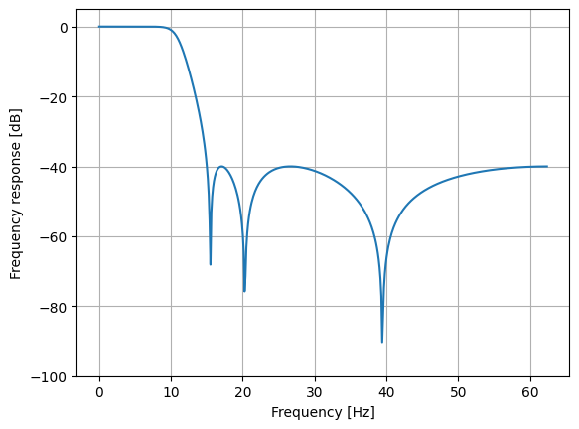
Figure 28. filter function for butter() function: b,a = scipy.signal.cheby2(6, 40, 15, btype='lowpass', analog=False, fs=125, output='ba')

